# 

Document Info 1

A. Step By Step Installation 2

System requirement 2

1. Download and Install Python Interpreter 2

2. Download JDK and Install 4

3. Download Eclipse 4

B. Download Examples 5

C. Configure your Interpreter 10

D. Your First PY File 14

E. Improve your Eclipse Speed If ‘Needed’ 18

F. Install PIP and Web component on Eclipse 20

Sample Web.py source code 22

# Document Info

**Purpose**:

DIY installation with restful services using both Python and Java

**Author:** CY Pan

**Date:** 8 November 2020

# A. Step By Step Installation

## System requirement

**OS** - Windows or Mac

**RAM** - 4 GB minimum

**CPU** - Intel i3 2nd generation above or not more than 7 years old computer

## **Download and Install Python Interpreter**

<https://www.python.org/ftp/python/3.9.0/python-3.9.0-amd64.exe>

Rerun [python-3.9.0-amd64.exe](https://www.python.org/ftp/python/3.9.0/python-3.9.0-amd64.exe) to configure the python on Windows

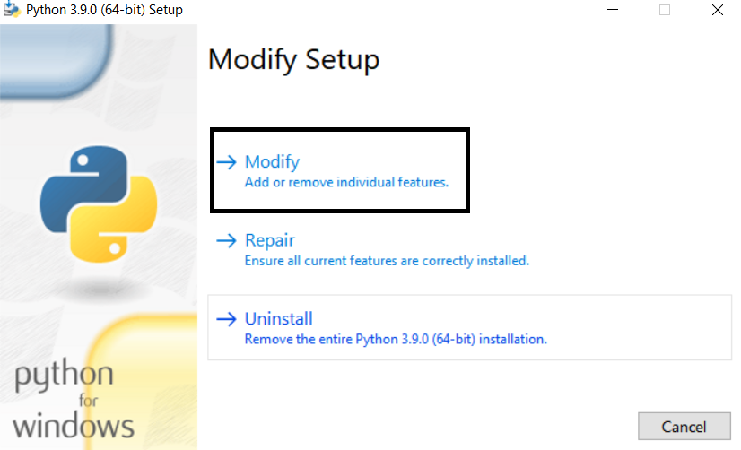

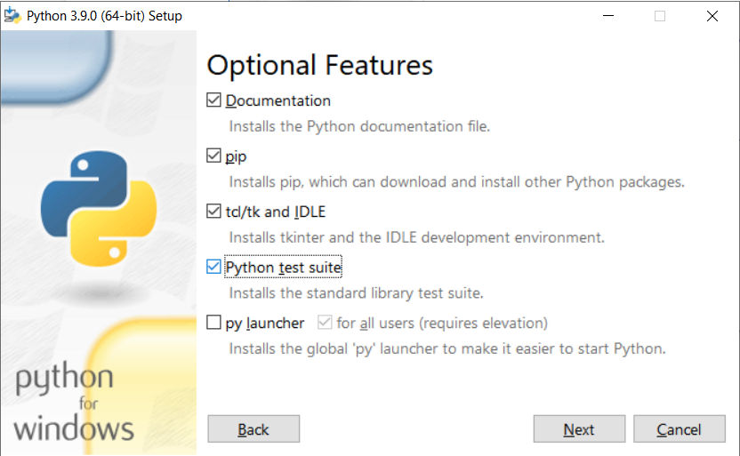

Click install

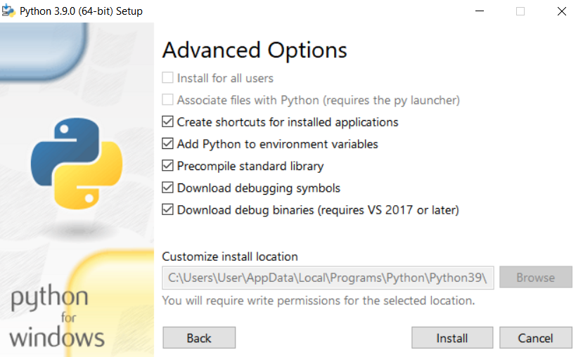

## **Download JDK and Install**

<https://drive.google.com/file/d/1v0mSNAyjA_haa9VrkF9e5NYa_zOyEI3b/view?usp=sharing>

## **Download Eclipse**

Download and Extract Eclipse to D: drive else install on C: drive

<https://drive.google.com/file/d/1LCauZQPIVIlJQL0gNgAeAuw5GZ2PBkRU/view?usp=sharing>

After eclipse is extracted, execute the eclipse.exe on the folder

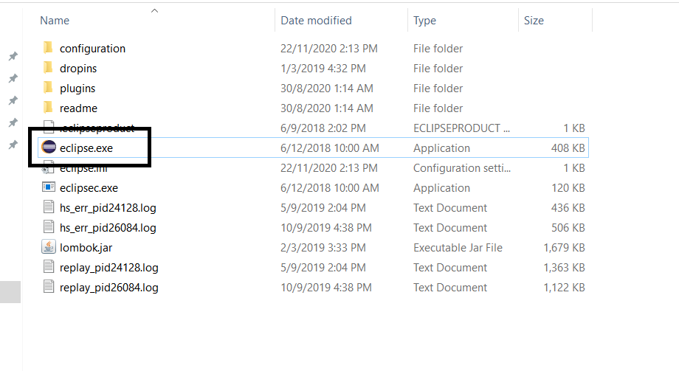

The Eclipse may ask you the default workspace then create on d:\workspace or c:\workspace

Click on the below after eclipse is started

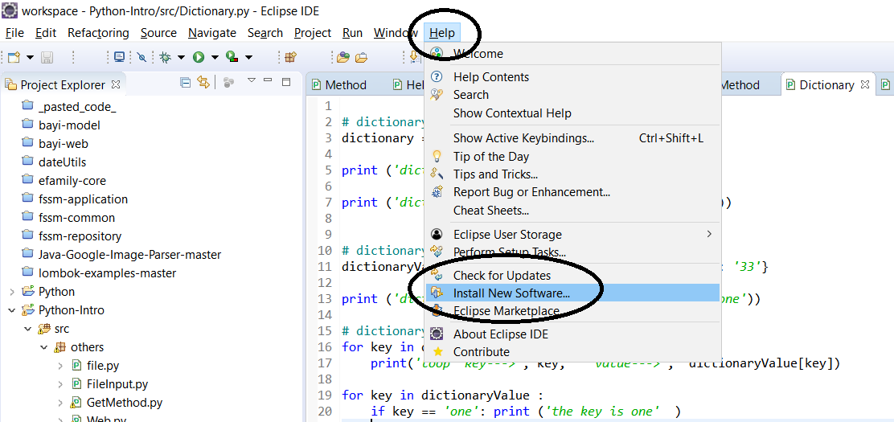

Type <http://pydev.org/updates> on below and press enter

Then Select the Pydev options below and click next. Click finish when done.

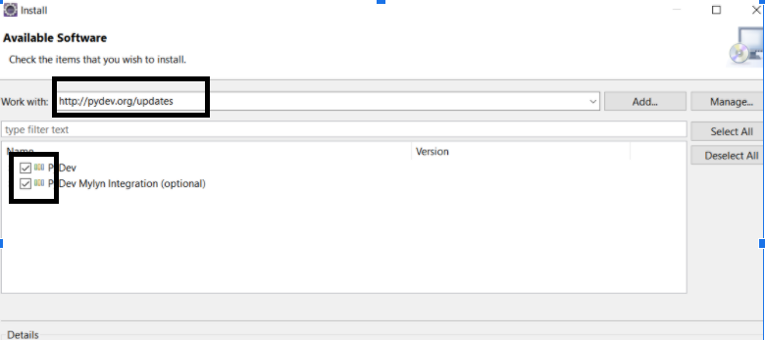

# B. Download Examples

1. Download the below and unzip to d:\workspace or c:\workspace

<https://github.com/pcyuen98/python-intro>

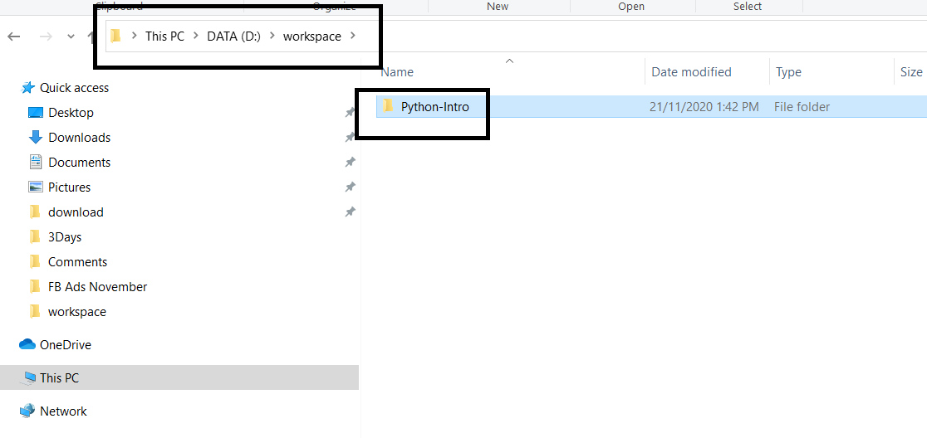

1. Import Project from Eclipse

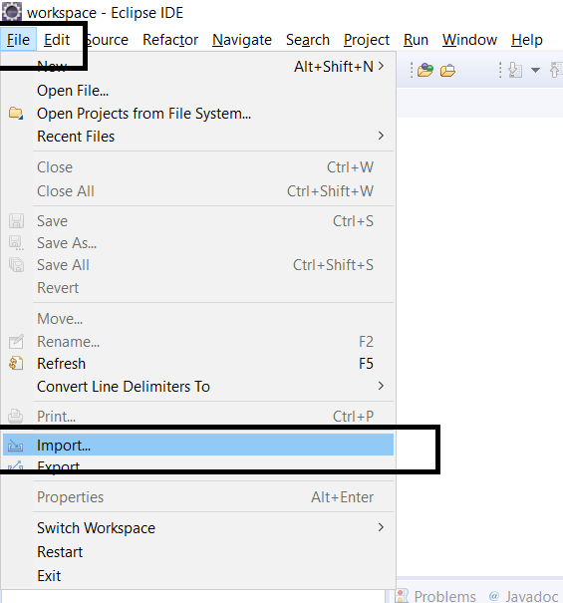

1. Browse the extracted Folder

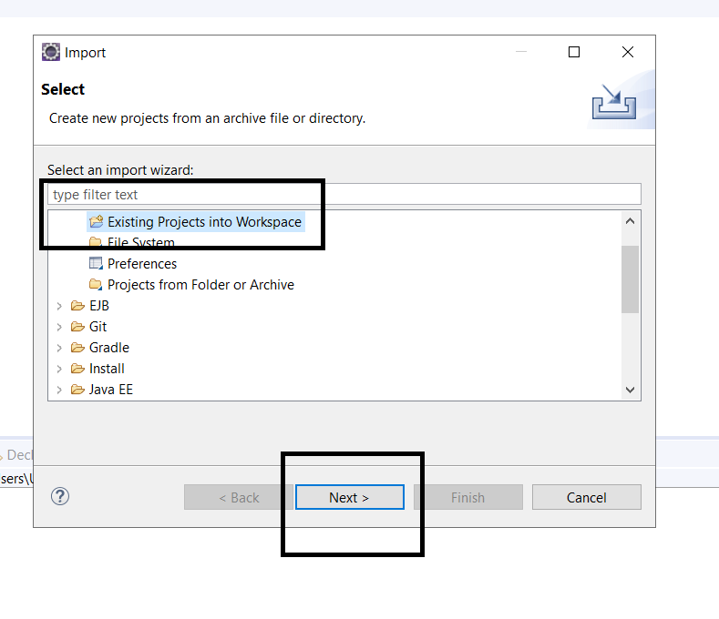

1. Select Folder and Click Finish

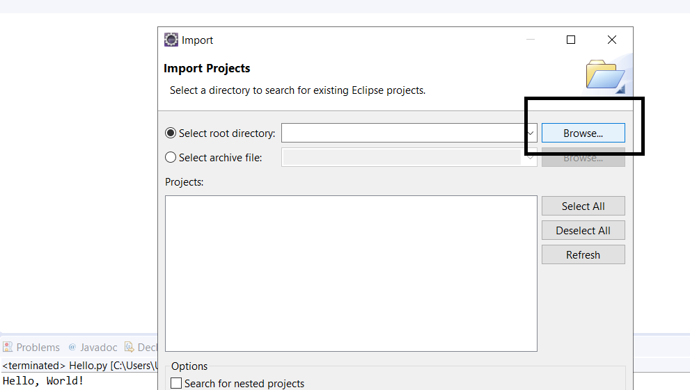

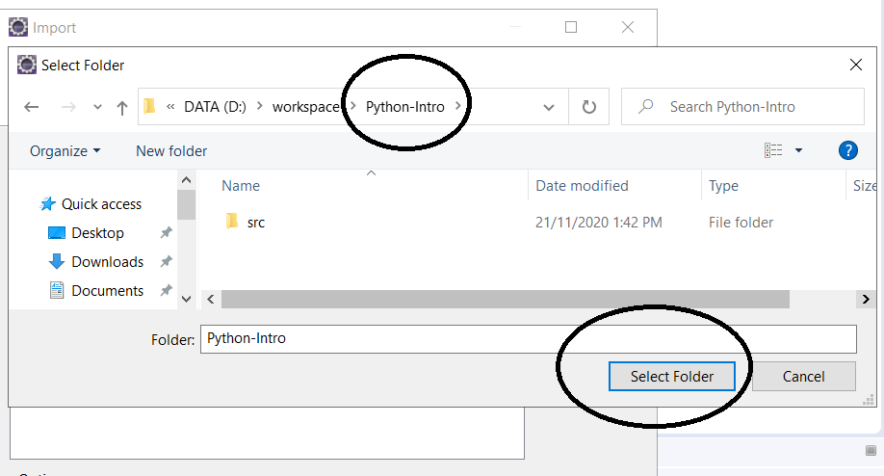

1. Double Click the Hello.py file and try to test python. If you see hello world at the bottom. Installation is a success !

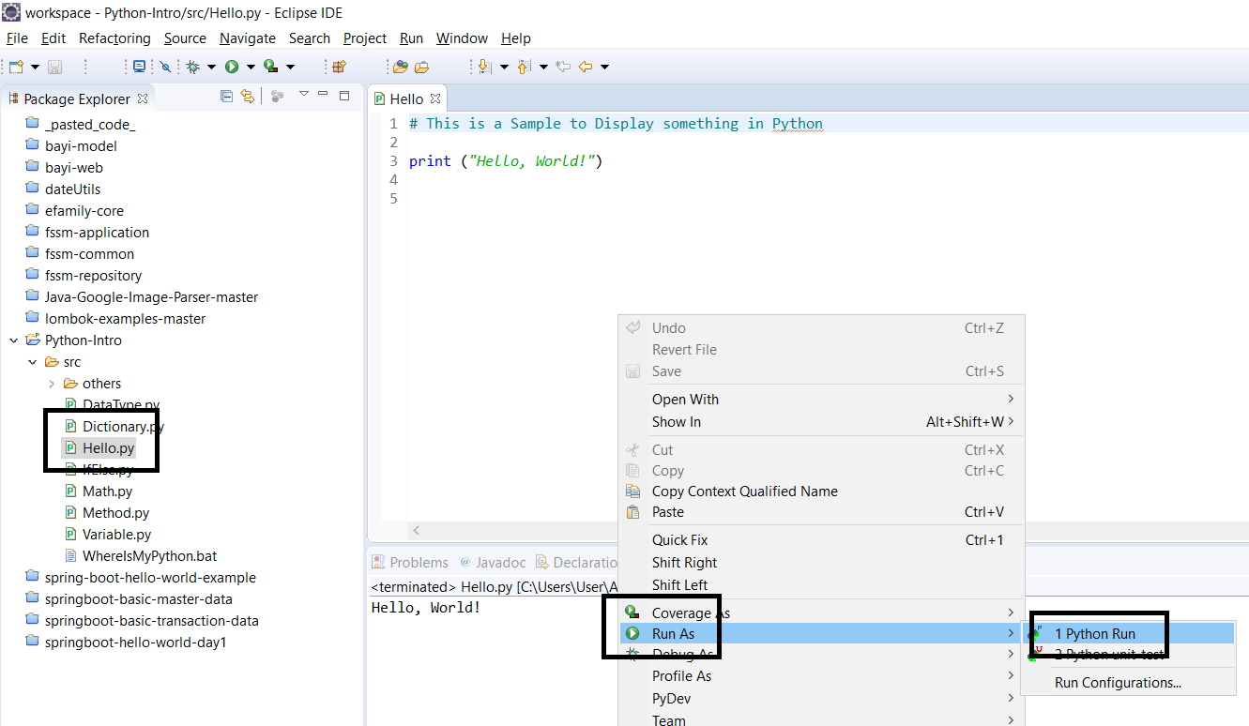

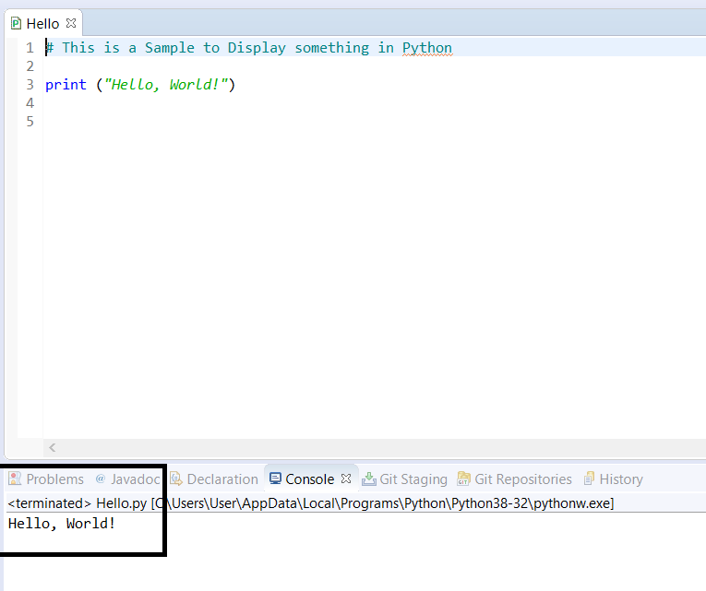

# C. Configure your Interpreter

1. If the above is not working. Likely From the Python Interpreter if not working. Click the below to check the path of your interpreter.

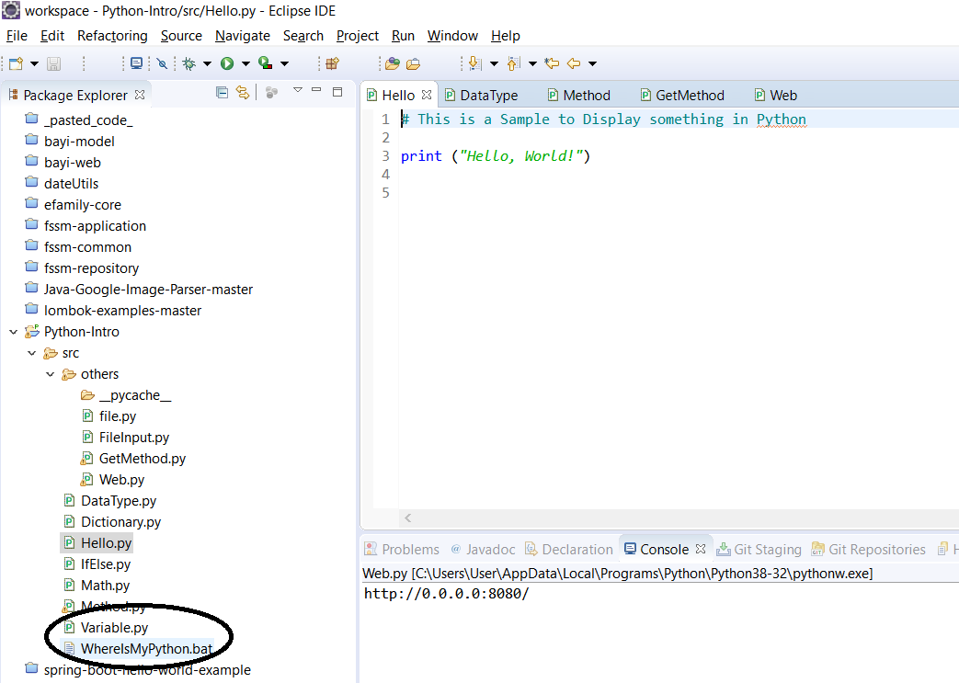

1. Highlight the below and copy the path

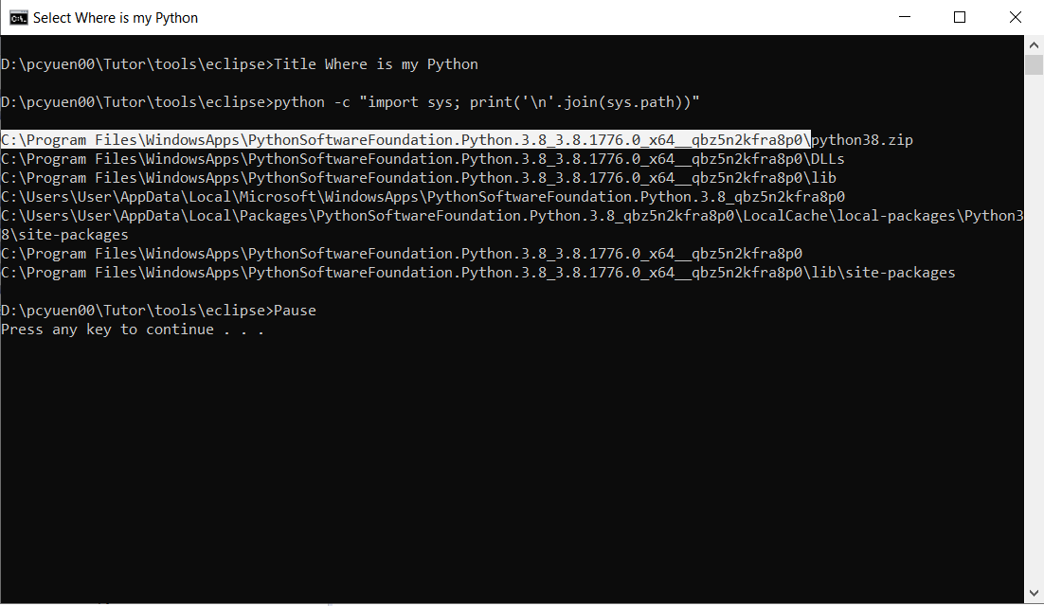

1. Click the below

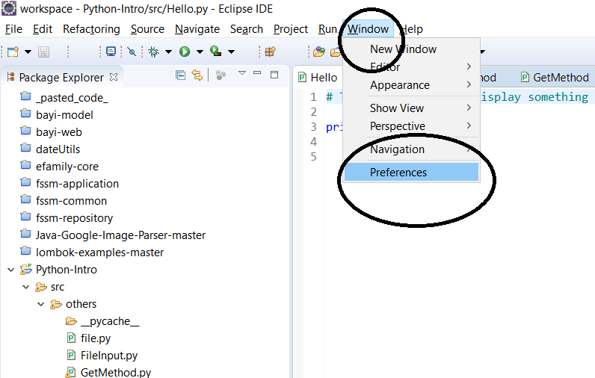

1. Select the below.

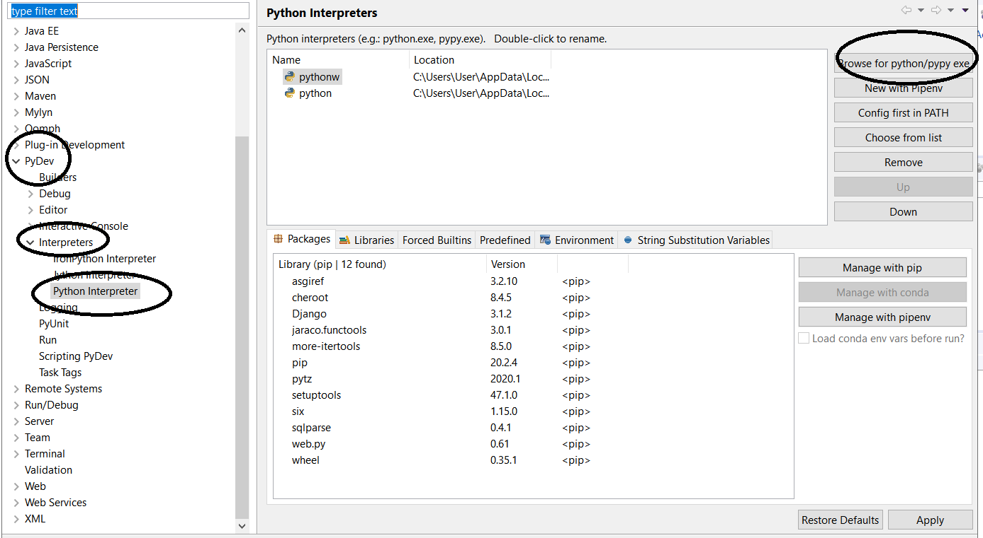

1. Paste the path you have selected from C.2 and select python.exe

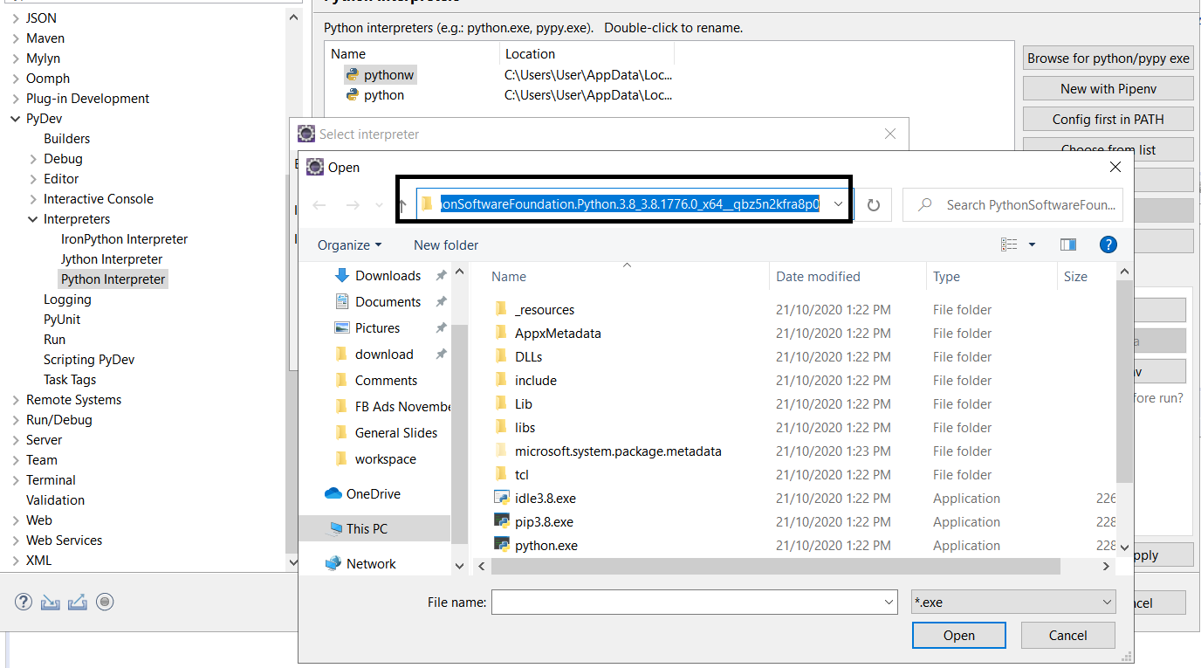

1. Key in Python as default name, click Apply.

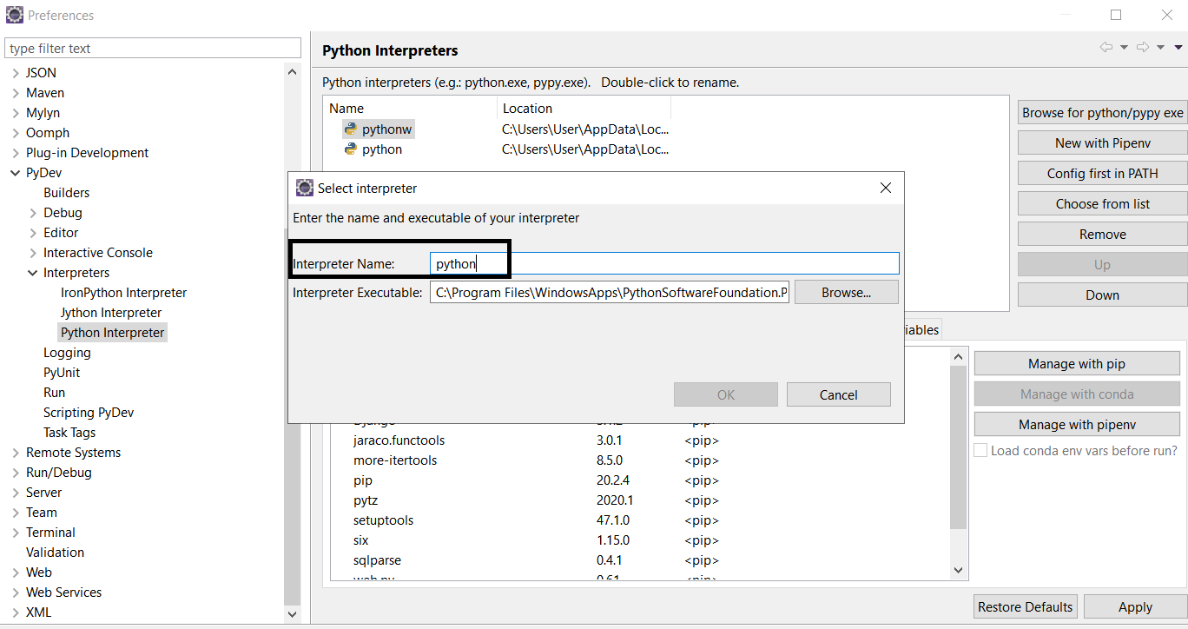

1. Only done, then go back to the project and run this again.



# D. Your First PY File

Select the below

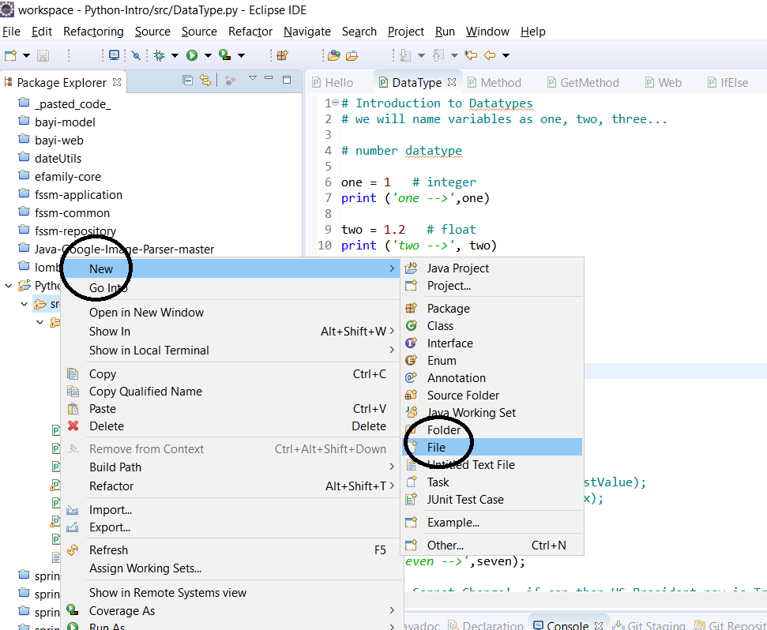

Key in any name and click finish.

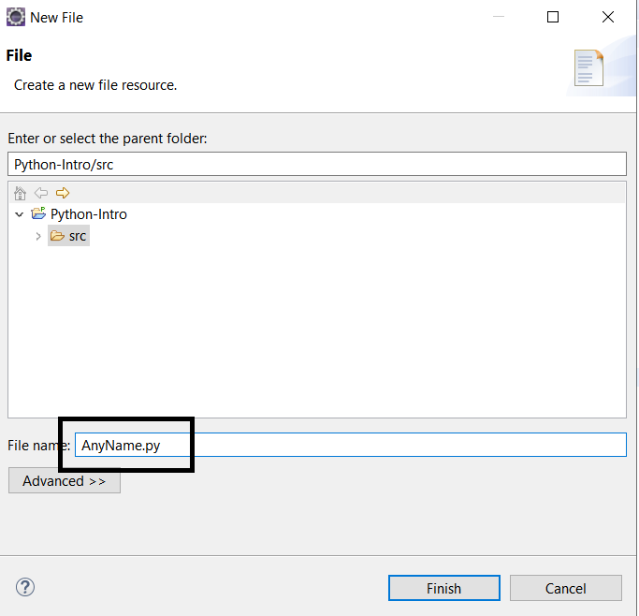

Find any example from any website, copy, and paste it it- i.e https://www.studytonight.com/python/modules-and-functions

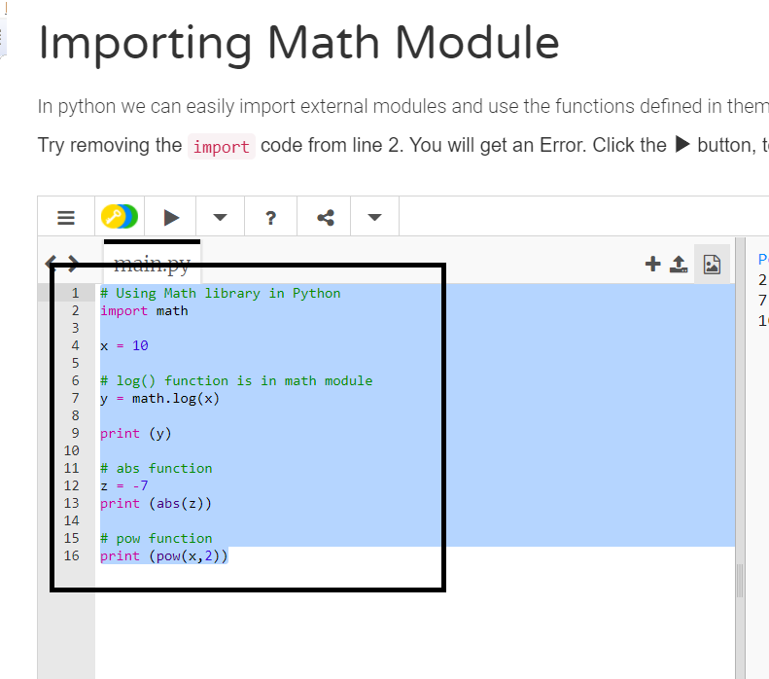

Past it on your newly created file anyname.py and run it!

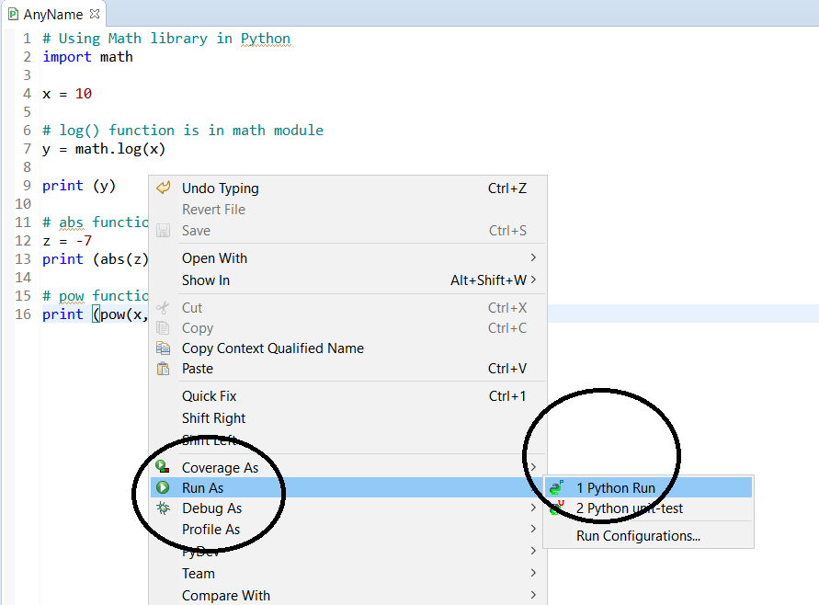

# E. Improve your Eclipse Speed If ‘Needed’

Close your Ellipse and Locate your Eclipse folder and ini file. Open it

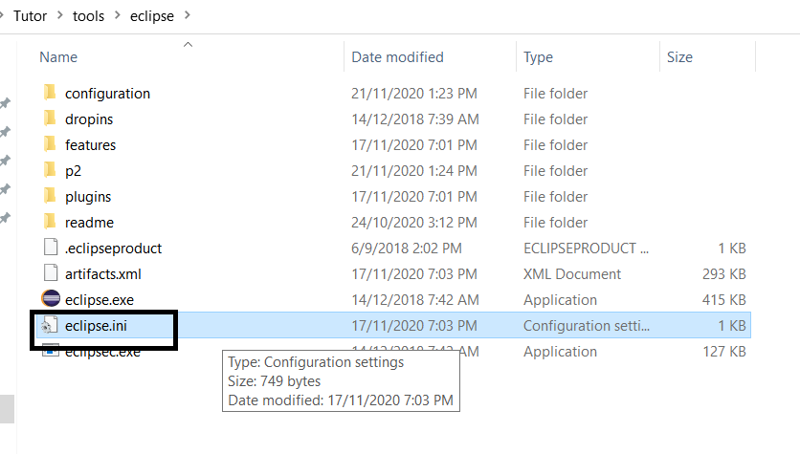

Change the below to both 256m which means only use 256 MBytes instead of 1GB. Simple and Basic programming doesn’t need 1 GB.

Adjust this only needed and make sure both value same, typically setting are 256m, 512m, 1024m, 2048m

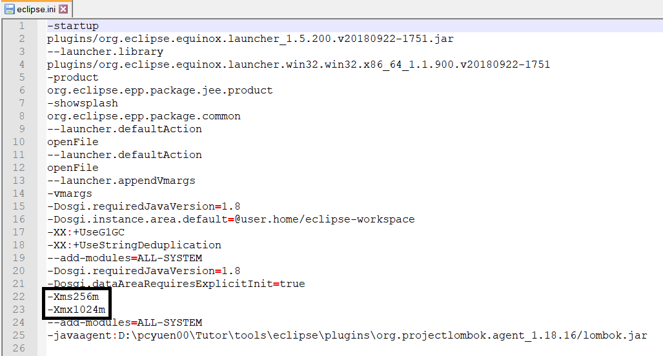

# F. Install PIP and Web component on Eclipse

PIP (Python Package Index) is the service and a subset of Python interpreters to install or upgrade new components just like your Android Apps Play store. I.e. Web component, AI, Gaming, IOT, etc

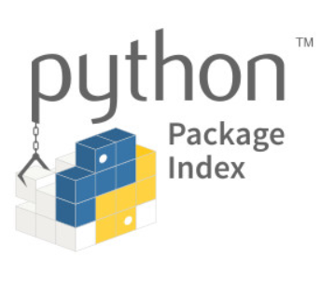

Click on the below

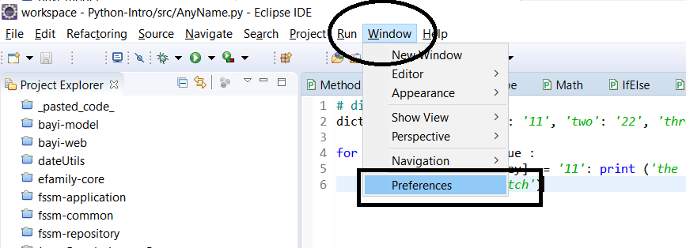

Click the below

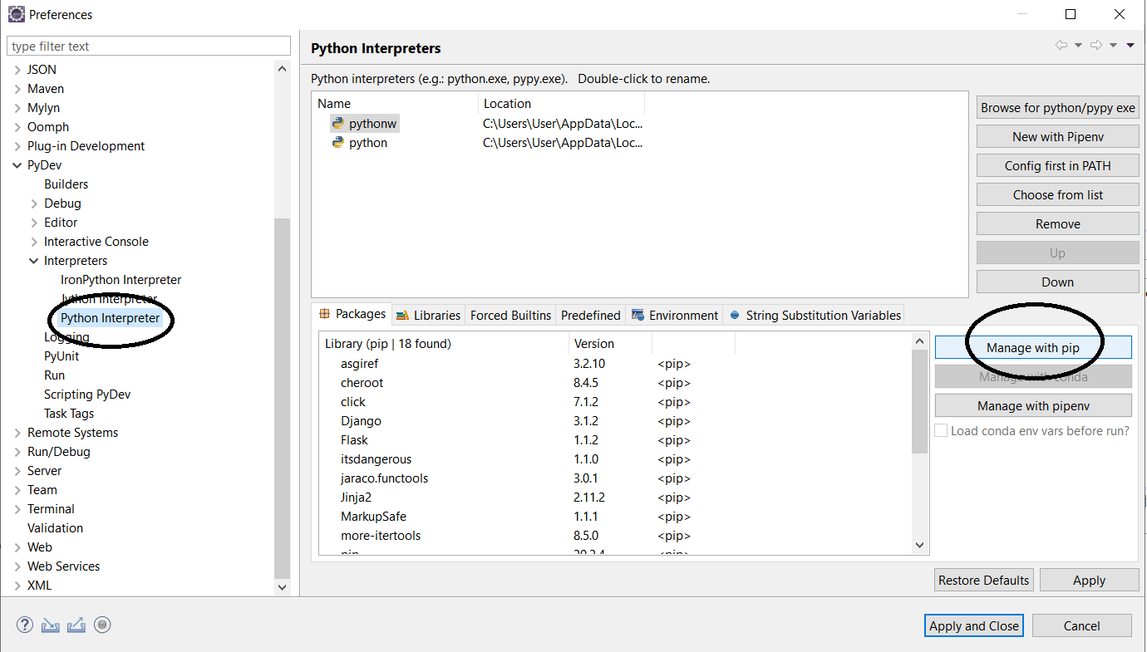

Enter below and press enter and ensure you receive the message on the executing box below then click apply and close.

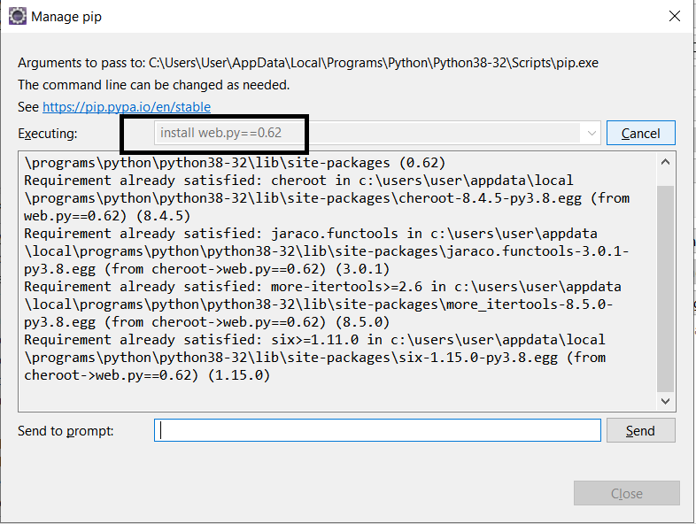

## Sample Web.py source code

import web

urls = (

'/', 'index1' # the index1 is mapping to the class name below on line 4

)

class index1: # is mapping to line 4

def GET(self): # is get method for web or retrieve something from web

import GetMethod # import something from GetMethod py File

#return "Hello Chrome 123!" # return simple message

return GetMethod.spartPart() # return GetMethod PY file and Spare Part Method

if __name__ == "__main__": # Standard Web Starter Instruction

app = web.application(urls, globals()) # Mapping to line 4 'urls' variable to tell Python

app.run() # Standard Web Starter Instruction